**Name :** Prachi Aggarwal

**Course :** B.Sc.(H) Computer Science

**Roll no :** 21570015

**Year :** Ist

**Subject Name :** Java Programming in JAVA

**Submitted to :** Ms. Kanishka

**Practical Questions**

**Q1) Design a class Complex having a real part(x) and an imaginary part (y). Provide methods to perform the following on complex numbers:**

* **Add two complex numbers**
* **Multiply two complex numbers**
* **toString() method to display complex numbers in the form x + iy.**

Ans)

import java.util.*;

public class Complex {

    int real,img;

    public Complex(int r, int i)

    {

        real=r ;

        img=i;

    }

    public static Complex add(Complex c1, Complex c2)

    {

        Complex held = new Complex(0,0);

        held.real = c1.real+c2.real;

        held.img= c1.img + c2.img;

        return held;

    }

    public static Complex mul(Complex c1,Complex c2)

    {

        Complex res = new Complex(1,1);

        res.real = (c1.real*c2.real)- (c1.img*c2.img);

        res.img = (c1.real*c2.img) + (c1.img*c2.real);

        return res;

    }

    public String toString(){

        return real+"+i"+img;

    }

    public static void main(String[] args) {

        System.out.println("Enter the real part and imaginary part respectively");

        Scanner sc= new Scanner(System.in);

        int a,b ;

        a=sc.nextInt();

        b=sc.nextInt();

        Complex num1 = new Complex(a,b);

        System.out.println("Enter the real part and imaginary part of second respectively");

        int c,d ;

        c=sc.nextInt();

        d=sc.nextInt();

        Complex num2 = new Complex(c,d);

        System.out.println("First Complex Number");

        System.out.println(num1);

        System.out.println("Second Complex Number");

        System.out.println(num2);

        Complex num3= add(num1,num2);

        System.out.println("The sum of two complex numbers");

        System.out.println(num3);

        Complex num4 = mul(num1,num2);

        System.out.println("The product of two complex number");

        System.out.println(num4);

    }

}

**OUTPUT**

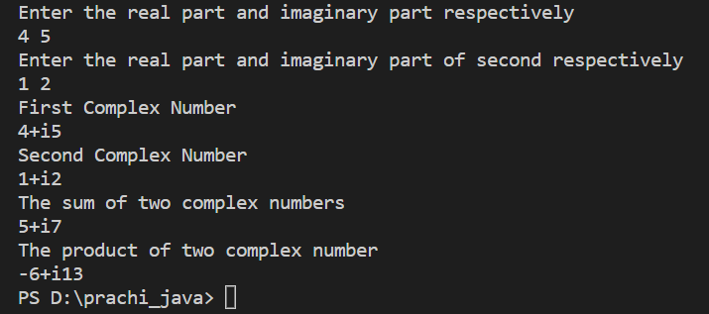

**Q2) Create a class TwoDim which contains private members as x and y coordinates in package P1. Define the default constructor, a parameterized constructor and override toString() method to display the co-ordinates. Now reuse this class and in package P2 create another class ThreeDim, adding a new dimension as z as its private member. Define the constructors for the subclass and override toString() method in the subclass also. Write appropriate methods to show dynamic method dispatch. The main() function should be in a package P.**

Ans)

TwoDim.java file in package p1

package p1;

import java.util.*;

public class TwoDim{

    private static int x;

    private static int y;

    public TwoDim(){

        x=0;

        y=0;

    }

    public TwoDim(int a, int b){

        x=a;

        y=b;

    }

    public String toString()

    {

        return "x= "+ x + "\ny = " + y;

    }

    public void toshow(){

        System.out.println("x= "+ x+ " y= "+y);

    }

}

ThreeDim.java File in package p2

package p2;

import p1.TwoDim;

import java.util.*;

public class ThreeDim extends TwoDim{

    private static int z;

    public ThreeDim(){

        super();

        z=0;

    }

    public ThreeDim( int m, int n,int l){

        super(m,n);

        z=l;

    }

    public String toString()

    {

        return "\nz= " + z;

    }

    public void toshow(){

        super.toshow();

        System.out.println("z= "+z);

    }

}

TwoThree.java (containing main function) in package p

package p ;

import p1.TwoDim;

import p2.ThreeDim;

import java.util.*;

public class TwoThree{

    public static void main(String[] args){

        TwoDim t;

        TwoDim t1 = new TwoDim(1,2);

        t=t1;

        t.toshow();

        // System.out.println(t1);

        ThreeDim t2 = new ThreeDim(3,4,5);

        t=t2;

        t.toshow();

        // System.out.println(t2);

    }

}

Packages:

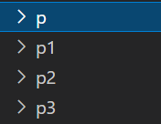

OUTPUT

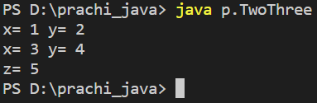

**Q3) Define an abstract class Shape in package P1. Inherit two more classes: Rectangle in package P2 and Circle in package P3. Write a program to ask the user for the type of shape and then using the concept of dynamic method dispatch, display the area of the appropriate subclass. Also write appropriate methods to read the data. The main() function should not be in any package.**

Ans)

Shape.java File in package p1

package p1;

import java.util.*;

abstract public class Shape {

    public static int l;

    public static int b;

    public static int r;

    abstract public void area();

}

Rectangle.java File in package p2

package p2;

import p1.Shape;

import java.util.*;

public class Rectangle extends Shape {

    public Rectangle()

    {

        l=0;

        b=0;

    }

    public Rectangle(int l, int b)

    {

        this.l= l;

        this.b=b;

    }

    public void area()

    {

        System.out.println("The area of rectangle is "+ l*b);

    }

}

Circle.java File in package p3

package p3;

import p1.Shape;

import java.util.*;

public class Circle extends Shape {

    public Circle()

    {

        r=0;

    }

    public Circle(int r)

    {

        this.r=r;

    }

    public void area()

    {

        System.out.println("The area of the circle is "+ 3.14*r*r);

    }

}

Main.java File (in which main function present)

import java.util.Scanner;

import p1.Shape;

import p2.Rectangle;;

import p3.Circle;

public class Main {

    public static void main(String[] args) {

        System.out.println("Enter the shape: 1.Rectangle 2.Circle");

        Scanner sc = new Scanner(System.in);

        int choice;

        choice = sc.nextInt();

        Shape s;

        int a,b,c;

        if(choice==1)

        {

            System.out.println("Enter the length and breath of rectangle");

            a=sc.nextInt();

            b=sc.nextInt();

            Rectangle r = new Rectangle(a,b);

            s=r;

            s.area();

        } else{

            System.out.println("Enter the radius of circle");

            c=sc.nextInt();

            Circle c1 = new Circle(c);

            s=c1;

            s.area();

        }

    }

}

OUTPUT

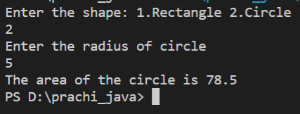

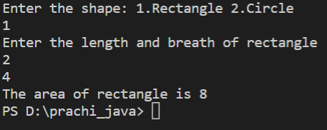

**Q4) Create an exception subclass UnderAge, which prints “Under Age” along with the age value when an object of UnderAge class is printed in the catch statement. Write a class exceptionDemo in which the method test() throws UnderAge exception if the variable age passed to it as argument is less than 18. Write main() method also to show working of the program.**

Ans)

import java.util.*;

class UnderAgeException extends Exception {

    int age;

    UnderAgeException(int a) {

        age=a;

    }

    public String toString(){

        return "UnderAge: "+age;

    }

}

public class exceptionDemo {

    static void test() throws UnderAgeException {

        int age;

        Scanner sc = new Scanner(System.in);

        System.out.println("Enter the age");

        age = sc.nextInt();

        if(age<18){

            throw new UnderAgeException(age);

        }

        System.out.println("Your age is "+age);

    }

    public static void main(String[] args) {

        try{

            test();

        }catch(Exception e){

            System.out.println(e);

        }

    }

}

OUTPUT

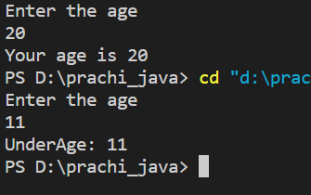

**Q5) Write a program to implement stack. Use exception handling to manage underflow and overflow conditions.**

Ans)

import java.util.*;

class StackException extends Exception{

    public StackException(String str){

        System.out.println(str);

    }

}

class Stack {

    int[] stck;//initialise stack

    int tos;//top of stack

    Stack(int s){

        stck = new int[s];//for inputting size by user

        tos=0;//set top of stack 0

    }

    void push(int item) throws StackException{

        if (tos == stck.length) {//reach at its capacity level

            throw new StackException("OverFlow");

        } else {

            stck[tos] = item;//pushing item into the stack

            tos++;//top stack number incremented

        }

    }

    int pop() throws StackException {

        int Return;

        if (tos == 0) {//all things come out

            throw new StackException("UnderFlow");

        }

        Return = stck[tos-1];//poping out the value at tos-1

        tos--;//then tos is decremented by 1

        return Return;//return the poping object

    }

}

public class TestStack {

    public static void main(String[] args) {

        int a;

        System.out.println("Enter the size of your stack");

        Scanner sc = new Scanner(System.in);

        int size = sc.nextInt();

        Stack s = new Stack(size);

        try{

            for(int i=0; i<=size; i++){

                System.out.println("Enter the element want to push");

                a=sc.nextInt();

                s.push(a);

            }

        }catch(StackException e){

            System.out.println(e.getMessage());

            // System.exit(0);

        }

        try{

            System.out.println("After popping");

            for(int j=0; j<=size ;j++){

                a=s.pop();

                System.out.println(a);

            }

        }catch(StackException e){

            System.out.println(e.getMessage());

        }

    }

}

OUTPUT

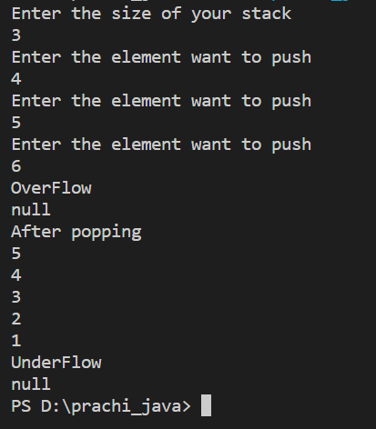

**Q6) Write a program that copies content of one file to another. Pass the names of the files through command-line arguments.**

Ans)

import java.io.*;

public class CopyingFile {

    public static void main(String[] args) {

        int i;

        if(args.length!=2){

            System.out.println("Usage: Copying file from");

            return;

        }

        try(FileInputStream fin = new FileInputStream(args[0]);FileOutputStream fout = new FileOutputStream(args[1]))

        {

            do{

                i=fin.read();

                if(i!=-1)

                    fout.write(i);

            }while(i!=-1);

        }catch(IOException e){

            System.out.println("I/O error "+e);

        }

    }

}

first.txt file

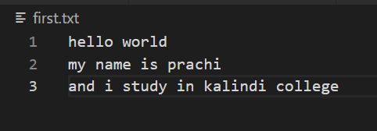

third.txt

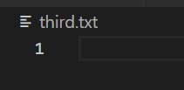

**OUTPUT**

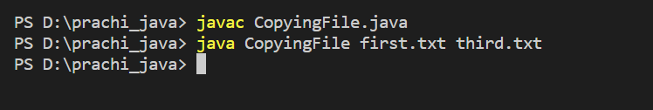

**File copied**

After compiling the file become

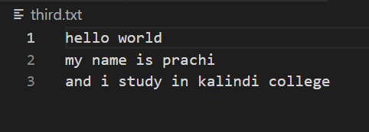

**Q7) Write a program to read a file and display only those lines that have the first two characters as '//' (Use try with resources).**

Ans)

import java.io.*;

import java.util.*;

public class ReadLineByLine {

    public static void main(String[] args) {

        int i;

        //Write a program to read a file and display only those lines that have the first two characters as

        // (Use try with resources)

        //check it is open or not

        if(args.length!=1){

            System.out.println("Usage: Showfile Filename");

            return ;

        }

        try(BufferedReader br = new BufferedReader(new FileReader(args[0]));

        FileInputStream fin = new FileInputStream(args[0])){

            i=fin.read();

            while(i!=-1)

            {

                i=fin.read();

                String current = br.readLine();

                char a1,a2;

                if(i==-1){

                    break;

                }

                a1=current.charAt(0);

                a2= current.charAt(1);

                if(a1=='/' && a2=='/'){

                    System.out.println(current);

                }

            }

        }catch(FileNotFoundException e){

            System.out.println("file not found"+e);

        }

        catch(IOException e){

            System.out.println("I/O error: "+e);

        }catch(NullPointerException e){

            System.out.println("null pointer excenption ");

        }

    }

}

second.txt File

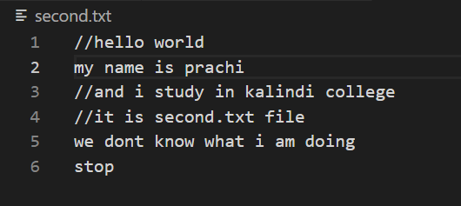

**OUTPUT**

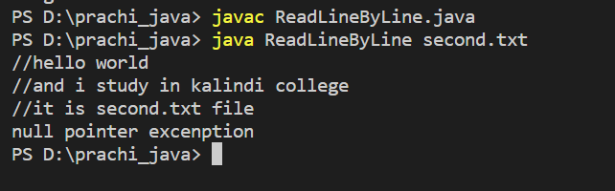

**Q8) Write a program to create a frame using AWT. Implement mouseClicked(), mouseEntered() and mouseExited() events such that:**

1. **Size of the frame should be tripled when mouse enters it. b) Frame should reduce to its original size when mouse is clicked in it. c) Close the frame when mouse exits it.**

**Ans)**

import java.util.*;

import java.awt.event.*;

import java.awt.*;

public class Q8 extends Frame{

    String msg="";

    public Q8()

    {

        addMouseListener(new MyMouseAdapter(this));

        addMouseMotionListener(new MyMouseAdapter(this));

        addWindowListener(new MyWindowAdapter());

    }

    public void paint(Graphics g)

    {

        g.drawString(msg, 20, 80);

    }

    public static void main(String[] args) {

        Q8 appwin = new Q8();

        appwin.setSize(new Dimension(200,200));

        appwin.setVisible(true);

    }

}

class MyMouseAdapter extends MouseAdapter{

    Q8 demo;

    public MyMouseAdapter(Q8 demo)

    {

        this.demo = demo;

    }

    public void mouseClicked(MouseEvent me)

    {

        demo.msg = "Mouse Clicked";

        demo.setSize(new Dimension(200,200));

        demo.repaint();

    }

    public void mouseEntered(MouseEvent me)

    {

        demo.msg = "Mouse Entered";

        demo.setSize(new Dimension(600,600));

        demo.repaint();

    }

    public void mouseExited(MouseEvent me)

    {

        demo.msg = "Mouse Exited";

        demo.setVisible(false);

        demo.repaint();

    }

}

class MyWindowAdapter extends WindowAdapter

{

    public void windowClosing(WindowEvent me)

    {

        System.exit(0);

    }

}

**Output**

**After execution**

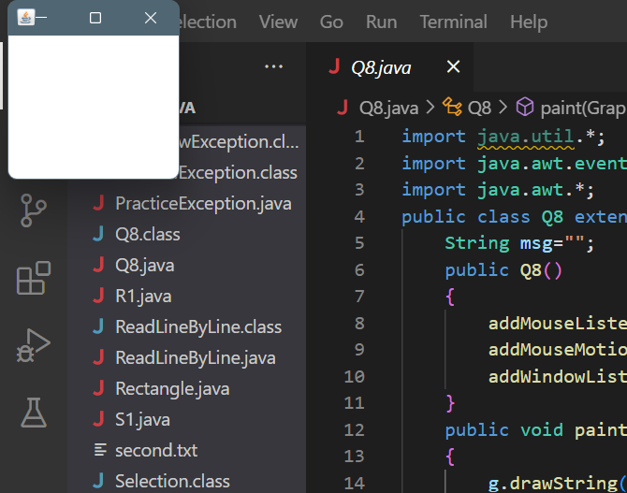

**When mouse entered in frame**

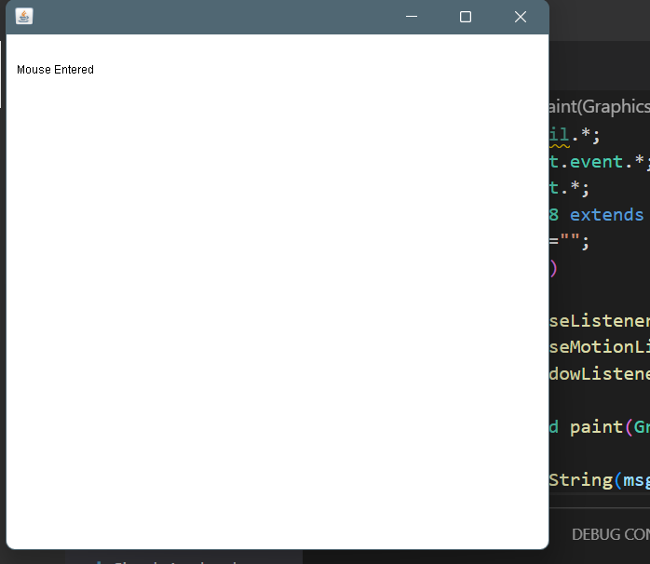

**When mouse clicked in frame**

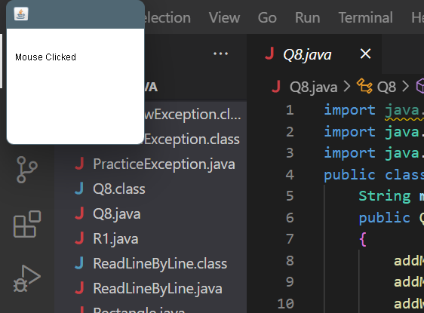

**When mouse exited from the frame**

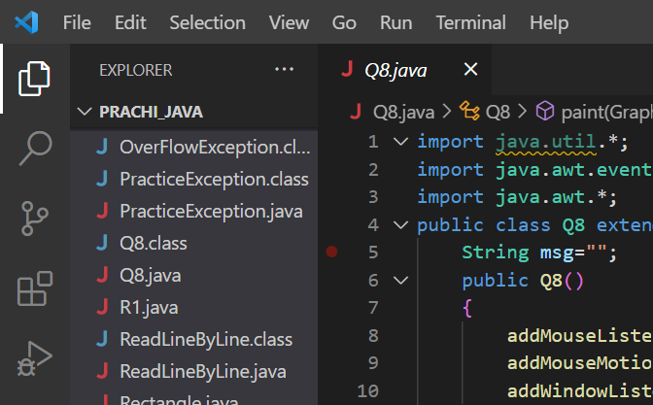

Q9) Using AWT, write a program to display a string in frame window with pink colour as background.

import java.util.*;

import java.awt.event.*;

import java.awt.*;

public class Background extends Frame{

    String msg ="";

    public Background()

    {

        setLayout(new FlowLayout());

        addWindowListener(new MyWindowAdapter());

    }

    public void paint(Graphics g)

    {

        g.drawString(msg, 100,100);

    }

    public static void main(String[] args) {

        Background back = new Background();

        back.setSize(new Dimension(800,200));

        back.setVisible(true);

        back.setBackground(Color.pink);

        String s ;

        Scanner sc = new Scanner(System.in);

        s= sc.next();

        Label l1=new Label  (s);

        back.add(l1);

    }

}

class MyWindowAdapter extends WindowAdapter

{

    public void windowClosing(WindowEvent me)

    {

        System.exit(0);

    }

}

**Output**

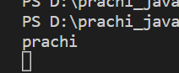**input**

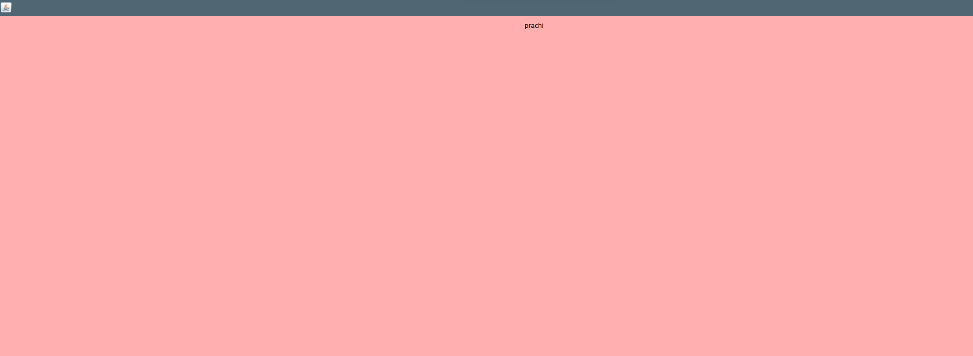

**Q10) Using AWT, write a program to create two buttons named “Red” and “Blue”. When a button is pressed the background color should be set to the color named by the button’s label.**

**Ans)**

import java.awt.*;

import java.awt.event.*;

public class ButtonDemo extends Frame implements ActionListener{

    String msg="";

    Button red,blue;

    public ButtonDemo()

    {

        setLayout(new FlowLayout());

        red = new Button("Red");

        blue = new Button("Blue");

        add(red);

        add(blue);

        red.addActionListener(this);

        blue.addActionListener(this);

        addWindowListener(new WindowAdapter(){

            public void windowClosing(WindowEvent we)

            {

                System.exit(0);

            }

        });

    }

    public void actionPerformed(ActionEvent ae)

    {

        String str = ae.getActionCommand();

        if(str.equals("Red"))

        {

            setBackground(Color.red);

        }

        else{

            setBackground(Color.blue);

        }

    }

    public void paint(Graphics g)

    {

        g.drawString(msg,100,100);

    }

    public static void main(String[] args) {

        ButtonDemo bd = new ButtonDemo();

        bd.setSize(new Dimension(200,200));

        bd.setTitle("Button Colour");

        bd.setVisible(true);

    }

}

**Output**

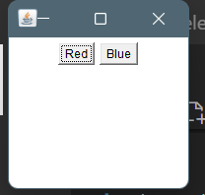

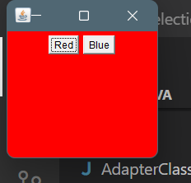

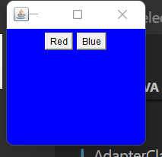

Q11) Using AWT, write a program using appropriate adapter class to display the message:

(Typed character is: <typed Character>) in the frame window when user types any key.

import java.awt.*;

import java.awt.event.*;

public class Typing extends Frame

{

    String msg = "";

    public Typing()

    {

        addKeyListener(new KeyAdapter(){

            public void keyTyped(KeyEvent ke)

            {

                msg = "Typed character is: "+ ke.getKeyChar();

                repaint();

            }

        });

        addWindowFocusListener(new WindowAdapter(){

            public void windowClosing(WindowEvent we)

            {

                System.exit(0);

            }

        });

    }

    public void paint(Graphics g)

    {

        g.drawString(msg, 200, 200);

    }

    public static void main(String[] args) {

        Typing t = new Typing();

        t.setSize(new Dimension(200,200));

        t.setVisible(true);

        t.setTitle("Q11");

    }

}

**Output**

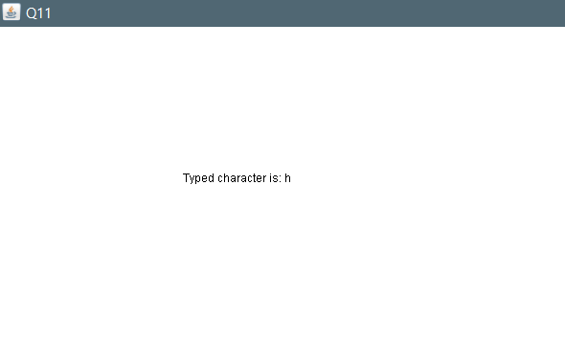

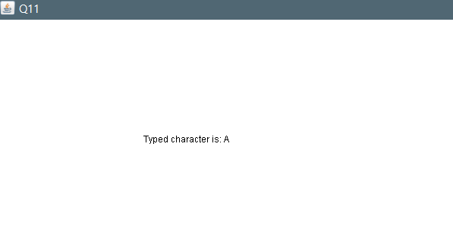

**Q12)Using AWT, write a program to create two buttons labelled ‘A’ and ‘B’. When button ‘A’ is pressed, it displays your personal information (Name, Course, Roll No, College) and when button ‘B’ is pressed, it displays your CGPA in previous semester.**

import java.awt.*;

import java.awt.event.*;

public class ButtonDetails extends Frame implements ActionListener{

    //Button A: Name, Course, Rollno, College

    //Button B: CGPA

    Button A,B;

    String msg= "";

    public ButtonDetails()

    {

        setLayout(new FlowLayout());

        A = new Button("A");

        B = new Button("B");

        add(A);

        add(B);

        A.addActionListener(this);

        B.addActionListener(this);

        addWindowListener(new WindowAdapter(){

            public void windowClosing(WindowEvent we)

            {

                System.exit(0);

            }

        });

    }

    public void actionPerformed(ActionEvent ae)

    {

        String str = ae.getActionCommand();

        if(str.equals("A"))

        {

            msg = "Name: Prachi Aggarwal, Course: Bsc(H) Computer Science, Rollno: 21570015, College: Kalindi College";

        }

        else{

            msg = "CGPA of previous semester: 9";

        }

        repaint();

    }

    public void paint(Graphics g)

    {

        g.drawString(msg,20,100);

    }

    public static void main(String[] args) {

        ButtonDetails bd = new ButtonDetails();

        bd.setSize(new Dimension(200,200));

        bd.setVisible(true);

        bd.setTitle("Buttons A and B");

    }

}

**Output**

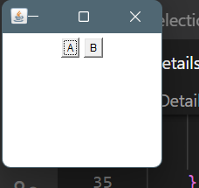

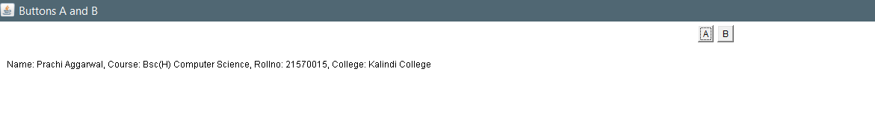

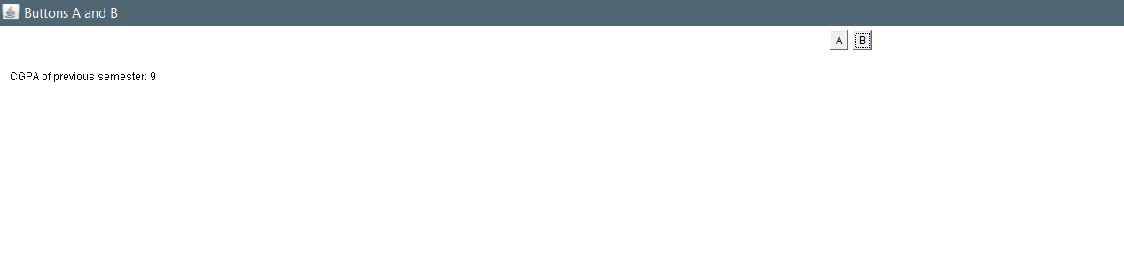

**Q13) Do all awt GUI programs using Swing.**

**(a)**

import java.awt.*;

import java.awt.event.*;

import javax.swing.*;

public class SwingBack {

    public static void main(String[] args) {

        JFrame j = new JFrame("Set Background");

        j.setSize(400,400);

        j.setLayout(new FlowLayout());

        j.getContentPane().setBackground(Color.pink);

        j.setDefaultCloseOperation(JFrame.EXIT_ON_CLOSE);

        JLabel jlab = new JLabel();

        jlab.setText("Hello");

        j.add(jlab);

        j.setVisible(true);

    }

}

**Output**

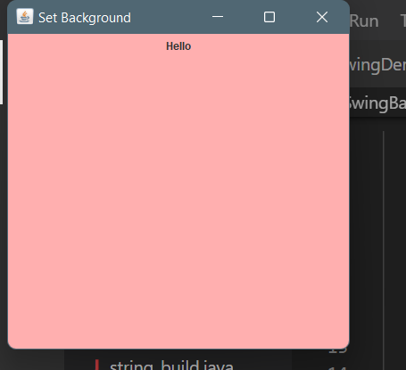

**(b)**

import java.awt.*;

import java.awt.event.*;

import javax.swing.*;

public class EventSwingDemo {

    public static void main(String[] args) {

        JFrame jfrm = new JFrame("EventHandling Using Swing");

        jfrm.setSize(275,200);

        jfrm.setLayout(new FlowLayout());

        jfrm.setDefaultCloseOperation(JFrame.EXIT_ON_CLOSE);

        JLabel jlab = new JLabel();

        JButton Red = new JButton("Red");

        JButton Blue = new JButton("Blue");

        Red.addActionListener(new ActionListener(){

            public void actionPerformed(ActionEvent ae){

                jfrm.getContentPane().setBackground(Color.red);

            }

        });

        Blue.addActionListener(new ActionListener(){

            public void actionPerformed(ActionEvent ae){

                jfrm.getContentPane().setBackground(Color.blue);

            }

        });

        jfrm.add(Red);

        jfrm.add(Blue);

        jfrm.setVisible(true);

    }

}

**Output**

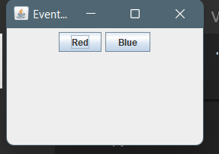

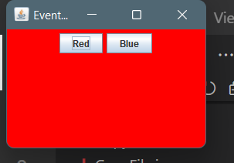

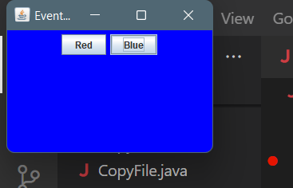

**(c)** import java.awt.*;

import java.awt.event.*;

import javax.swing.*;

public class ButtonSwing {

    public static void main(String[] args) {

        JFrame jfrm = new JFrame("EventHandling Using Swing");

        jfrm.setSize(275,200);

        jfrm.setLayout(new FlowLayout());

        jfrm.setDefaultCloseOperation(JFrame.EXIT_ON_CLOSE);

        JLabel jlab = new JLabel();

        JButton A = new JButton("A");

        JButton B = new JButton("B");

        jfrm.add(A);

        jfrm.add(B);

        A.addActionListener(new ActionListener(){

            public void actionPerformed(ActionEvent ae){

                jlab.setText("Name: Prachi Aggarwal, Course: Bsc(H) Computer Science, Rollno: 21570015, College: Kalindi College");

                jfrm.add(jlab);

            }

        });

        B.addActionListener(new ActionListener(){

            public void actionPerformed(ActionEvent ae){

                jlab.setText("CGPA: 9");

                jfrm.add(jlab);

            }

        });

        jfrm.setVisible(true);

    }

}

**Output**

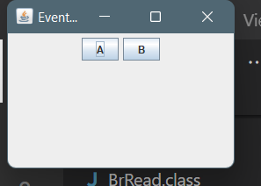

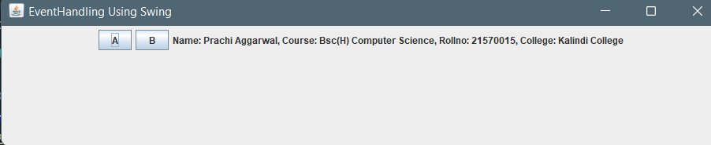

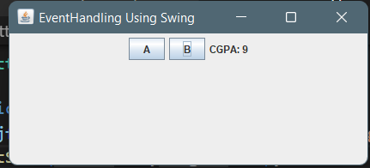

**(d)**

import java.awt.*;

import java.awt.event.*;

import javax.swing.*;

public class MouseEventSwing {

    public static void main(String[] args) {

        new EventHandle();

    }

}

class EventHandle extends JFrame

{

    JLabel lab;

    EventHandle()

    {

        addMouseListener(new MouseAdapter(){

            public void mouseClicked(MouseEvent me)

            {

                lab = new JLabel("Mouse Clicked");

                add(lab);

                setSize(200,200);

            }

            public void mouseEntered(MouseEvent me)

            {

                lab = new JLabel("Mouse Entered");

                add(lab);

                setSize(600,600);

            }

            public void mouseExited(MouseEvent me)

            {

                lab = new JLabel("Mouse Exited");

                add(lab);

                System.exit(0);

            }

        });

        setSize(200, 200);

        setDefaultCloseOperation(JFrame.EXIT_ON_CLOSE);

        setVisible(true);

    }

}

**Output**

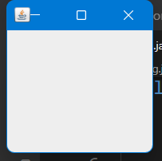

**Mouse entered**

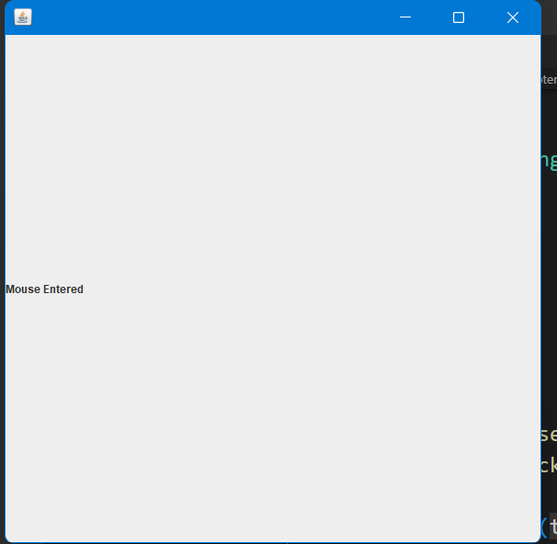

**Mouse clicked**



**(e)**

import java.awt.*;

import java.awt.event.*;

// import java.awt.Graphics;

import javax.swing.*;

public class mykey{

    public static void main(String[] args) {

        new KeyEvent();

    }

}

class KeyEvent extends JFrame implements ActionListener{

    JLabel lab = new JLabel("TYPED CHARACTERS : ");

    JLabel lab2;

    JTextField t = new JTextField(10);

    KeyEvent()

    {

        add(lab);

        t.addActionListener(this);

        add(t);

        setSize(400,400);

        setDefaultCloseOperation(JFrame.EXIT_ON_CLOSE);

        setVisible(true);

        setLayout(new FlowLayout());

    }

    public void actionPerformed(ActionEvent ae)

    {

        lab2.setText(t.getText());

        add(lab2);

    }

}

**Output**

